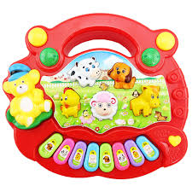

New born baby’s love these type of toys. Kid’s piano is a cheap toy for small kids. This piano consist of such beautiful colors and animals . Small babies love this piano.

Product : Kid’s Piano

Price: 700 PKR

CONTACT US: Address: Aptech Metro star Gate Karachi

Email: feedback@aptech-education.com.pk